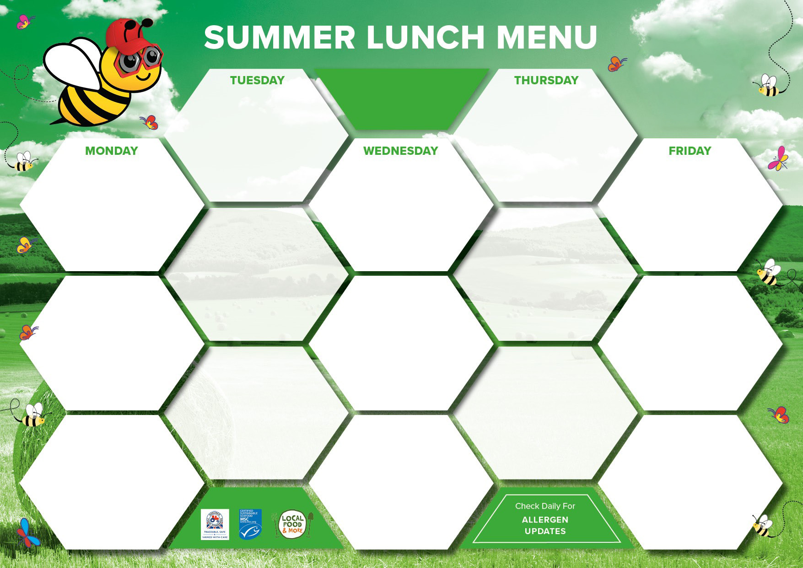

|  |  |  |  |  |
| --- | --- | --- | --- | --- |
|  | All Day Breakfast  Veggie All Day Breakfast (V)    Jacket Potato | **WEEK 1**  COMMENCING  2nd June, 23rd June,  14th July | Roast Chicken & Stuffing    Summer Quorn Roast (V)    Jacket Potato |  |
| Fajita Chicken Fried Rice  Mumbai potato Wraps &  Minted Yoghurt Relish (V)    Jacket Potato | Pork & Lentil Bolognaise  Cheese & Tomato Pinwheels (V)    Jacket Potato | Golden Fish Fingers    Vegetable Spring Roll &  Sweet Chilli Sauce (Ve)  Jacket Potato |
| Hash Browns  Baked Beans  Homemade Bread    Salad Bar | Roast Potatoes  Cabbage, Carrots  Homemade Bread    Salad Bar |
| Homemade  Garlic Bread    Green Beans, Cauliflower  Salad Bar | Wholemeal Pasta  Broccoli, Sweetcorn    Homemade Bread    Salad Bar | Chips  Garden Peas  Baked Beans  Homemade Bread    Salad Bar |
| Cornflake Cookie &  Milkshake    Strawberry Whip  Fresh Fruit & Yoghurt | Vanilla Crunch & Custard    Chocolate Pots  Fresh Fruit & Yoghurt |
| Banana Split    Jelly Pots  Fresh Fruit & Yoghurt | Tropical Fruit Meringue Nest & Cream    Jelly Pots  Fresh Fruit & Yoghurt | Assorted Desserts  (Please Check for Allergens)  Fresh Fruit & Yoghurt |

|  |  |  |  |  |
| --- | --- | --- | --- | --- |
|  | Homecooked assorted  Cold Meats  Cajun Sweet Potato  & Spinach Tart (V)    Jacket Potato | **WEEK 2**  COMMENCING  9th June, 30th June,  21st July | Roast Loin of Pork  & Stuffing    Lentil Roast (V)      Jacket Potato |  |
| Crispy Crumb  topped Macaroni Cheese (V)    Salmon & Pea Risotto    Jacket Potato | Beef Chilli Nachos  Felafel Pitta Bread (V)    Jacket Potato | Breaded Fish Fillet    Feta & Halloumi Filo  Parcel (V)      Jacket Potato |
| New Potatoes  Coleslaw, Mixed salad    Homemade Bread    Salad Bar | Roast Potatoes  Cauliflower Cheese, Green beans    Homemade Bread    Salad Bar |
| Homemade  Garlic Bread    Carrots, Broccoli  Salad Bar | Wholegrain Rice  Sweetcorn, Garden Peas  Homemade Bread    Salad Bar | Chips  Mushy Peas  Baked Beans  Homemade Bread    Salad Bar |
| Iced Sponge    Granola Pot  Fresh Fruit & Yoghurt | Apple & Raspberry Crumble  & Custard    Chocolate Mousse  Fresh Fruit & Yoghurt |
| Warm waffle with Summer  Berries & Ice cream      Jelly Pots  Fresh Fruit & Yoghurt | Strawberry Shortcake & Cream    Jelly Pots  Fresh Fruit & Yoghurt | Assorted Desserts  (Please Check for Allergens)  Fresh Fruit & Yoghurt |



|  |  |  |  |  |
| --- | --- | --- | --- | --- |
|  | Sausage Meat & Onion  Pie    Quorn Sausage with Onion Gravy  Jacket Potato | **WEEK 3**  COMMENCING  16th June, 7th July,  1st September | Roast Honey Glazed  Gammon & Yorkshire Puds    Stuffed Field Mushroom  (Ve)  Jacket Potato |  |
| BBQ Chicken & Bacon  Pasta Bake    Tuscan Beans on Sour Dough  Toast    Jacket Potato | Chicken Shawarma  Flatbread    Cheese & Potato Pie    Jacket Potato | Power Plant Nuggets    Veggie Burger  Jacket Potato |
| Mashed Potato    Carrots, Garden Peas    Homemade Bread    Salad Bar | Roast Potatoes  Broccoli, Roast Parsnips  Homemade Bread    Salad Bar |
| Homemade  Garlic Bread    Sweetcorn, Green beans  Salad Bar | Giant Couscous, Coleslaw  Mixed Salad    Salad Bar | Chips  Sweetcorn & Baked Beans  Homemade Bread    Salad Bar |
| Iced Buns    Butterscotch Whip  Fresh Fruit & Yoghurt | Red Berry Cheesecake    Strawberry Mousse  Fresh Fruit & Yoghurt |
| Blueberry & Lemon Muffin    Jelly Pots  Fresh Fruit & Yoghurt | Fresh Fruit Salad &  Frozen Yoghurts    Jelly Pots  Fresh Fruit & Yoghurt | Assorted Desserts  (Please Check for Allergens)  Fresh Fruit & Yoghurt |



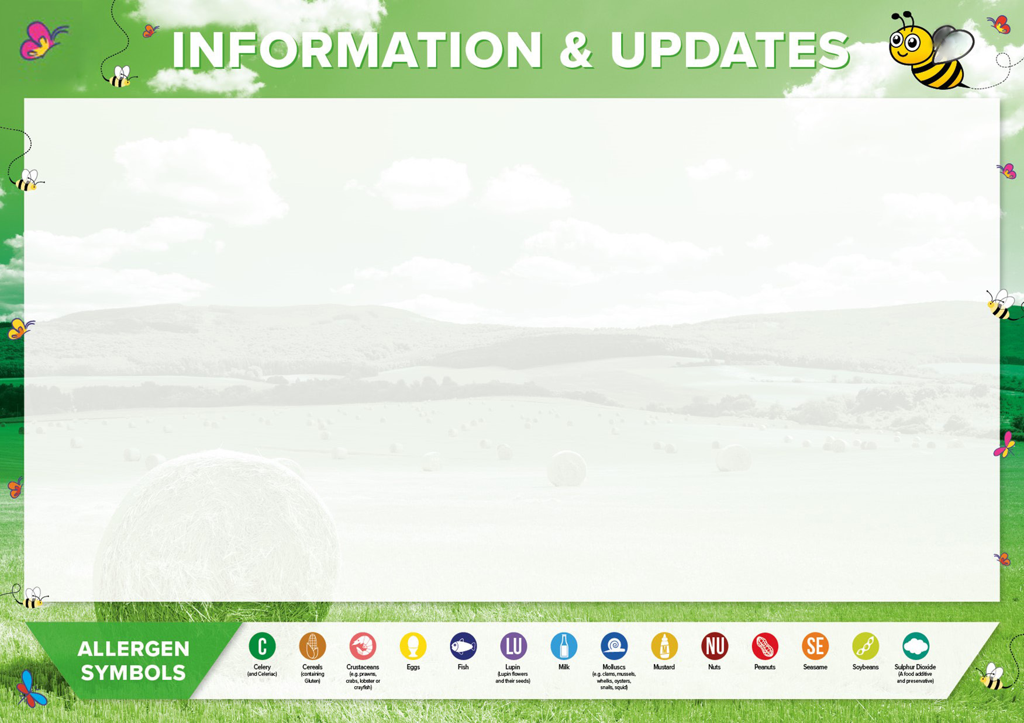

This Menu will commence after the Half-Term break, week beginning 2nd June.

Please keep an eye out for theme days & any menu changes which will be notified.

We are immensely proud to say that our menus have received the Food for Life Foundation Award, meaning they are fully compliant with School Food Standards & use wherever possible, fresh ingredients from local & trusted suppliers. We have also made a sustainable commitment to reduce the amount of red meat on our menus.

Please see our corresponding allergen chart below, which is highlighted on each week’s menus.

Should your child have a medically diagnosed allergy or health condition, please do let your school know & our fully trained teams will be happy to accommodate. (V) =Vegetarian, (VE) =Vegan. If you think your child may be eligible for free school meals, please visit; www.gov.uk/apply-free-school-meals

**SUMMER MENU 2025**