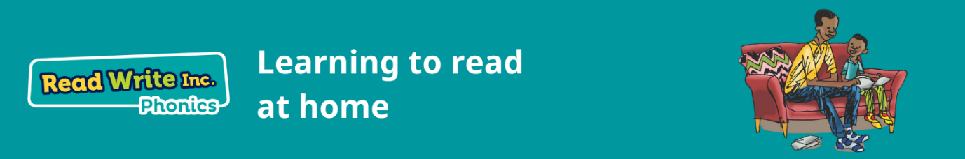

At stone Lodge we use Read, Write, Inc as the scheme to teach Phonics and reading in English.

There are lots of resources for parents on the Ruth Miskin website. Here is the link <https://www.ruthmiskin.com/parentsandcarers/>

Here there are videos explaining how to support your child at home with their reading.